#### Project 1: FizzBuzz

FizzBuzz is a simple programming task often helps practice loops, conditional statements, and the operator in Python.

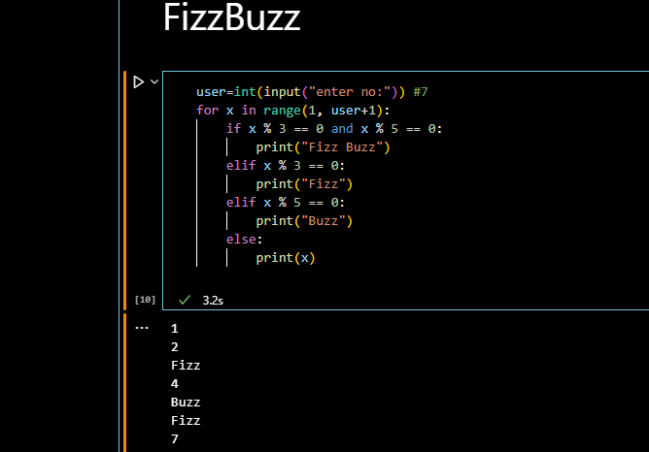

# Rules of FizzBuzz

1. If a number is divisible by 3, print 'Fizz'.

2. If a number is divisible by 5, print 'Buzz'.

3. If a number is divisible by both 3 and 5, print 'FizzBuzz'.

4. Otherwise, print the number itself.

# Explanation of the Code

1. We use a for loop with range(1, 101) to generate numbers from 1 to 100.

3. If the number is divisible by 3, we add 'Fizz' to output.

4. If the number is divisible by 5, we add 'Buzz' to output.

5. If the number is divisible by both, output becomes 'FizzBuzz'.

6. If output is still empty, we print the number itself.

7. Otherwise, we print the contents of output.